**Experiment 4.4**

**Aim:Working with directories,rename file,copy file**

Code:

1)Create a directory in current working directory

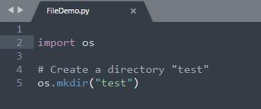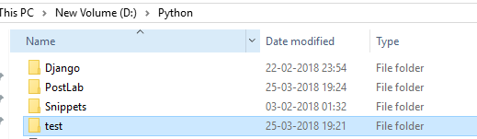

2)Change working directory and display current directory

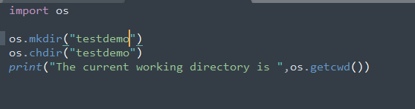



3)Remove a directory by passing file name as argument

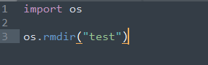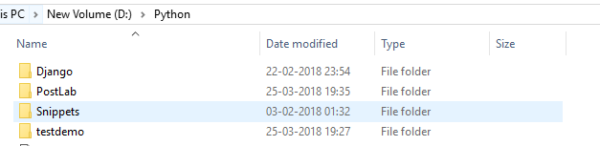

4)Rename a file and delete a file

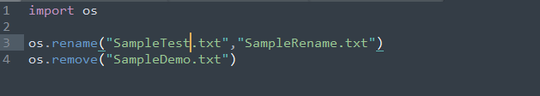

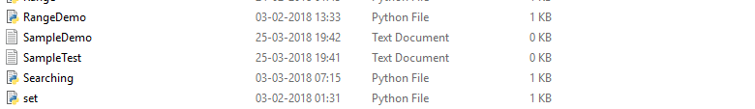

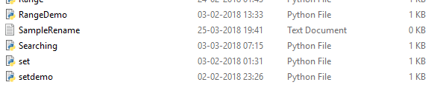

5)Copy contents of file

